**Department of Computer Engineering**



**Cairo University**

**Faculty of Engineering**

**ELC 325B – Spring 2023**

**Digital Communications**

**Assignment #2**

***Submitted to***

Dr. Mai

Dr. Hala

Eng. Mohamed Khaled

***Submitted by***

|  |  |  |  |
| --- | --- | --- | --- |
| **Name** | **Sec** | **BN** | **Code** |
| **Abdelrahman Hamdy Ahmed** | **1** | **36** | **9202833** |
| **Zeyad Tarek Khairy** | **1** | **28** | **9202588** |

Contents

**Hand Analysis for Part 1:…………** 3

**Hand Analysis for Part 2:…………** 7

**Filter 1 Output:…………** 12

**Filter 2 Output:…………** 13

**Filter 3 Output:…………** 13

**Theoretical and Simulated BER:…………** 14

**Hand Analysis – Part 1**

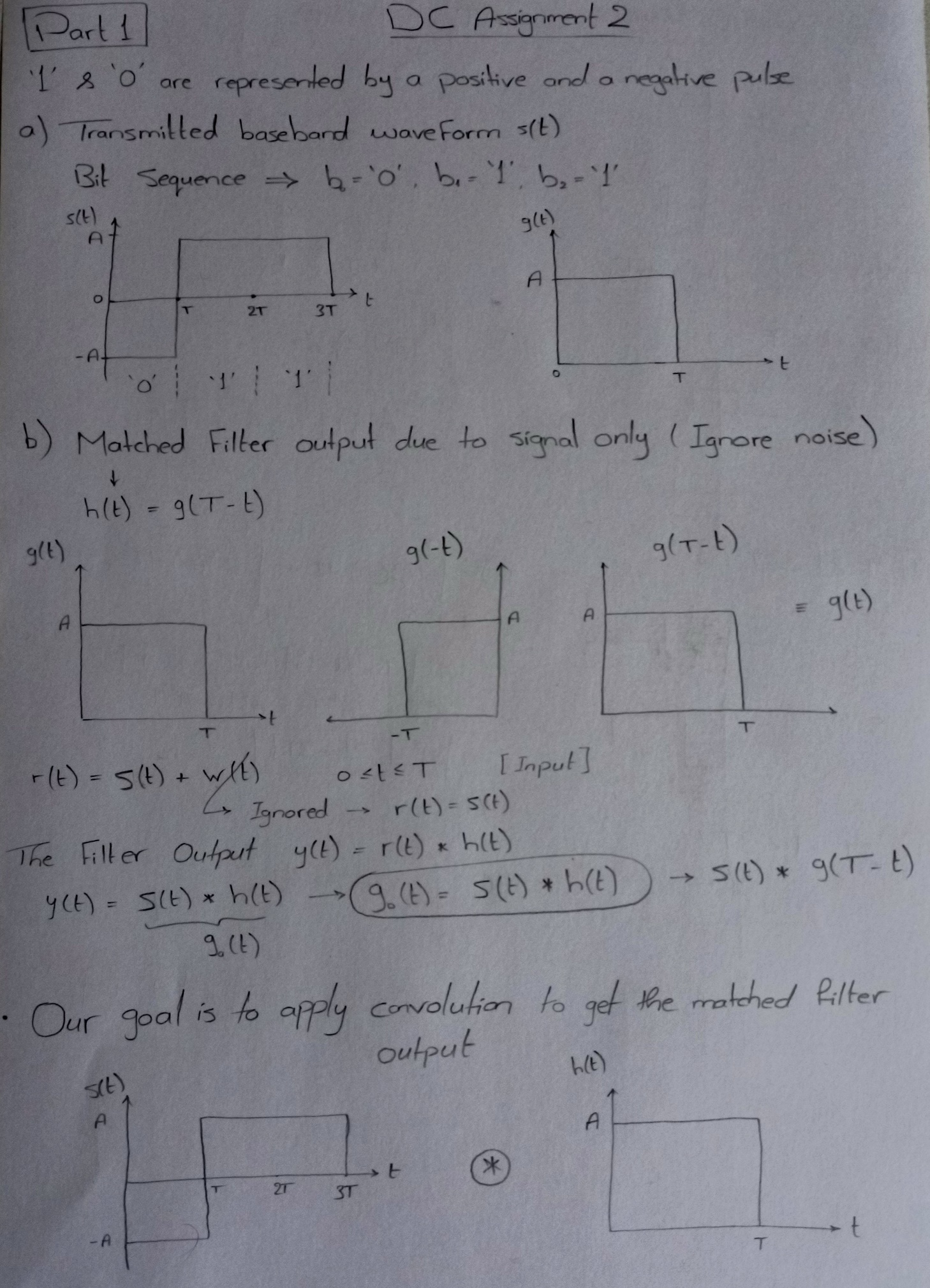

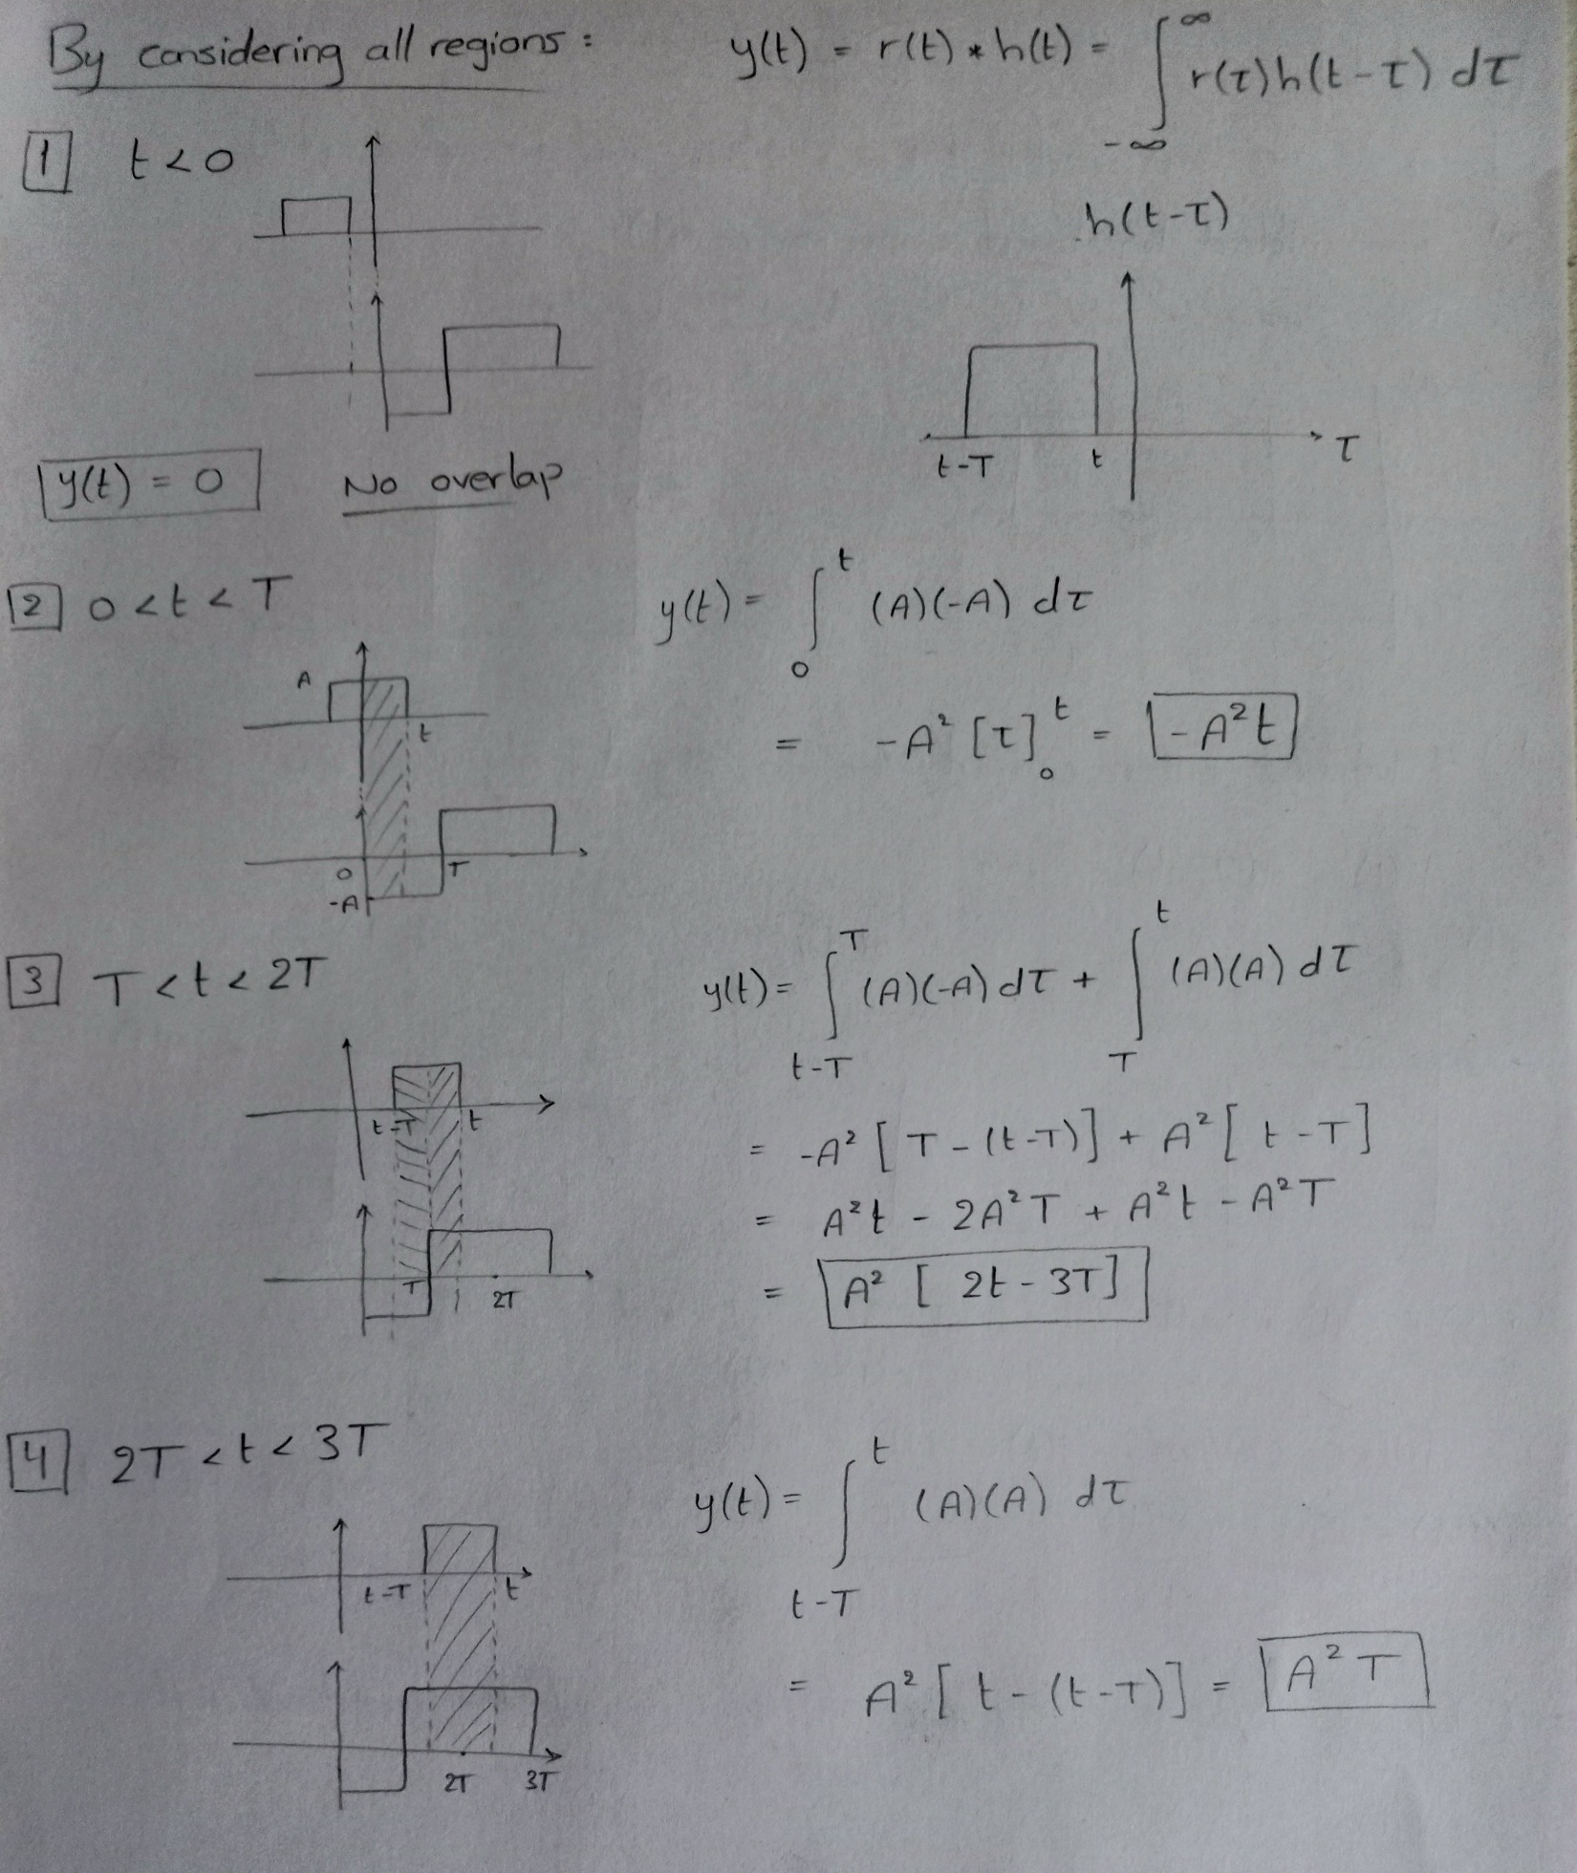

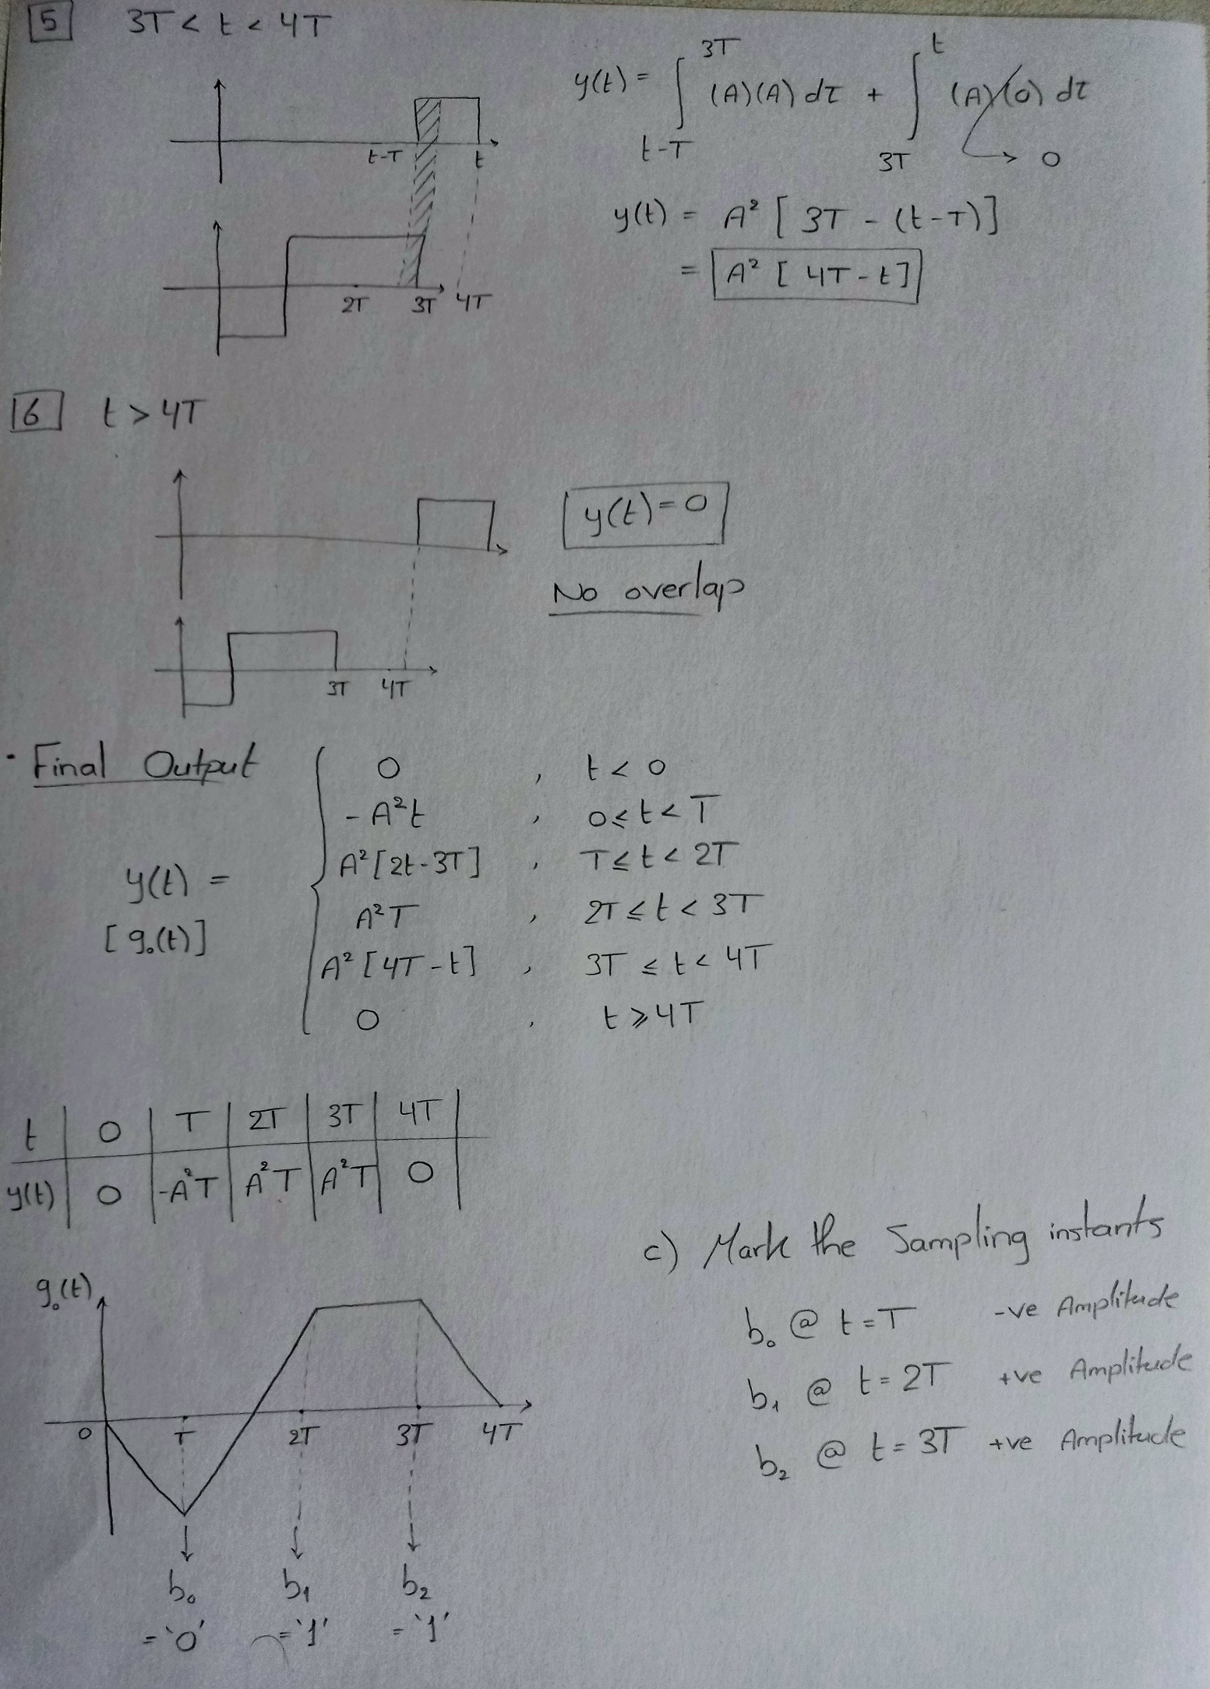

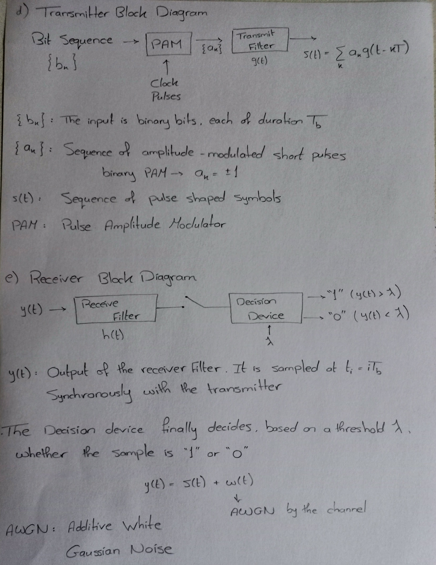

**Hand Analysis – Part 2**

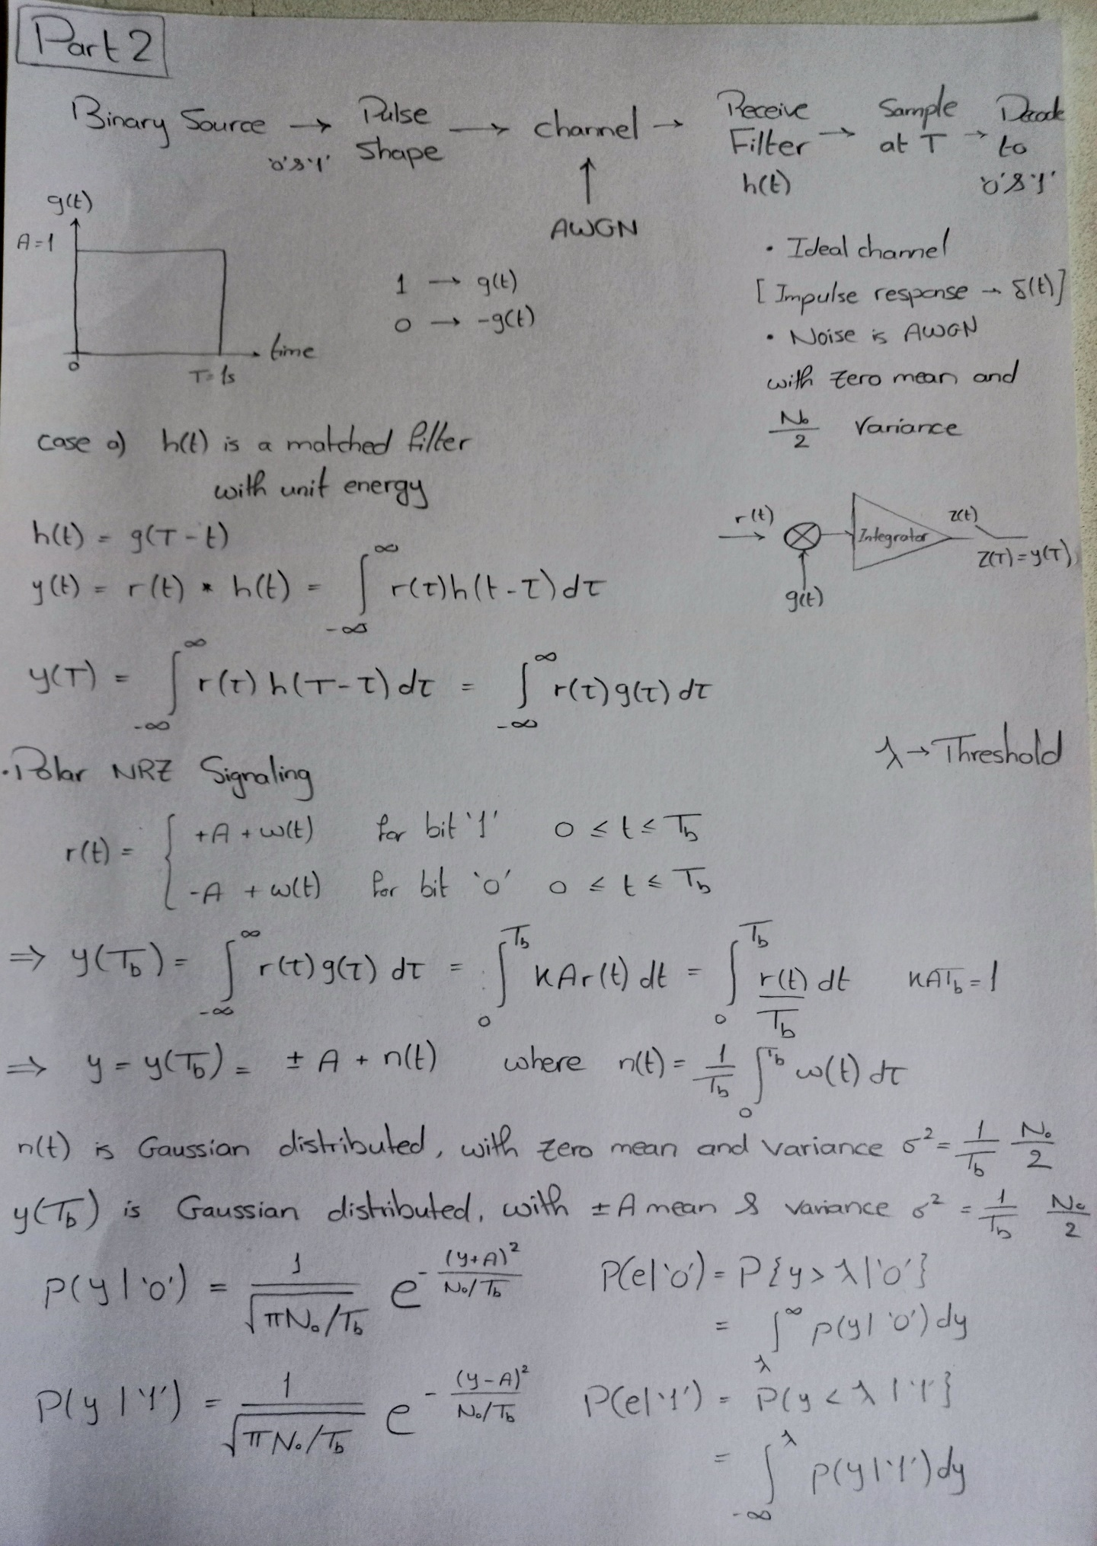

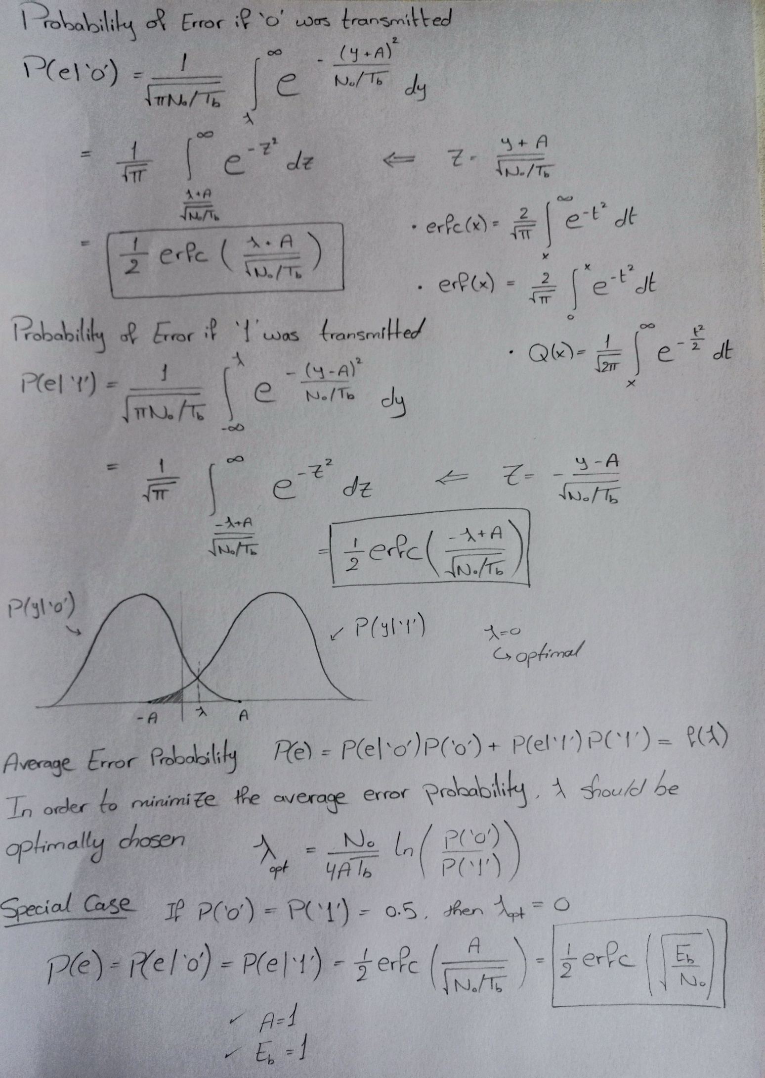

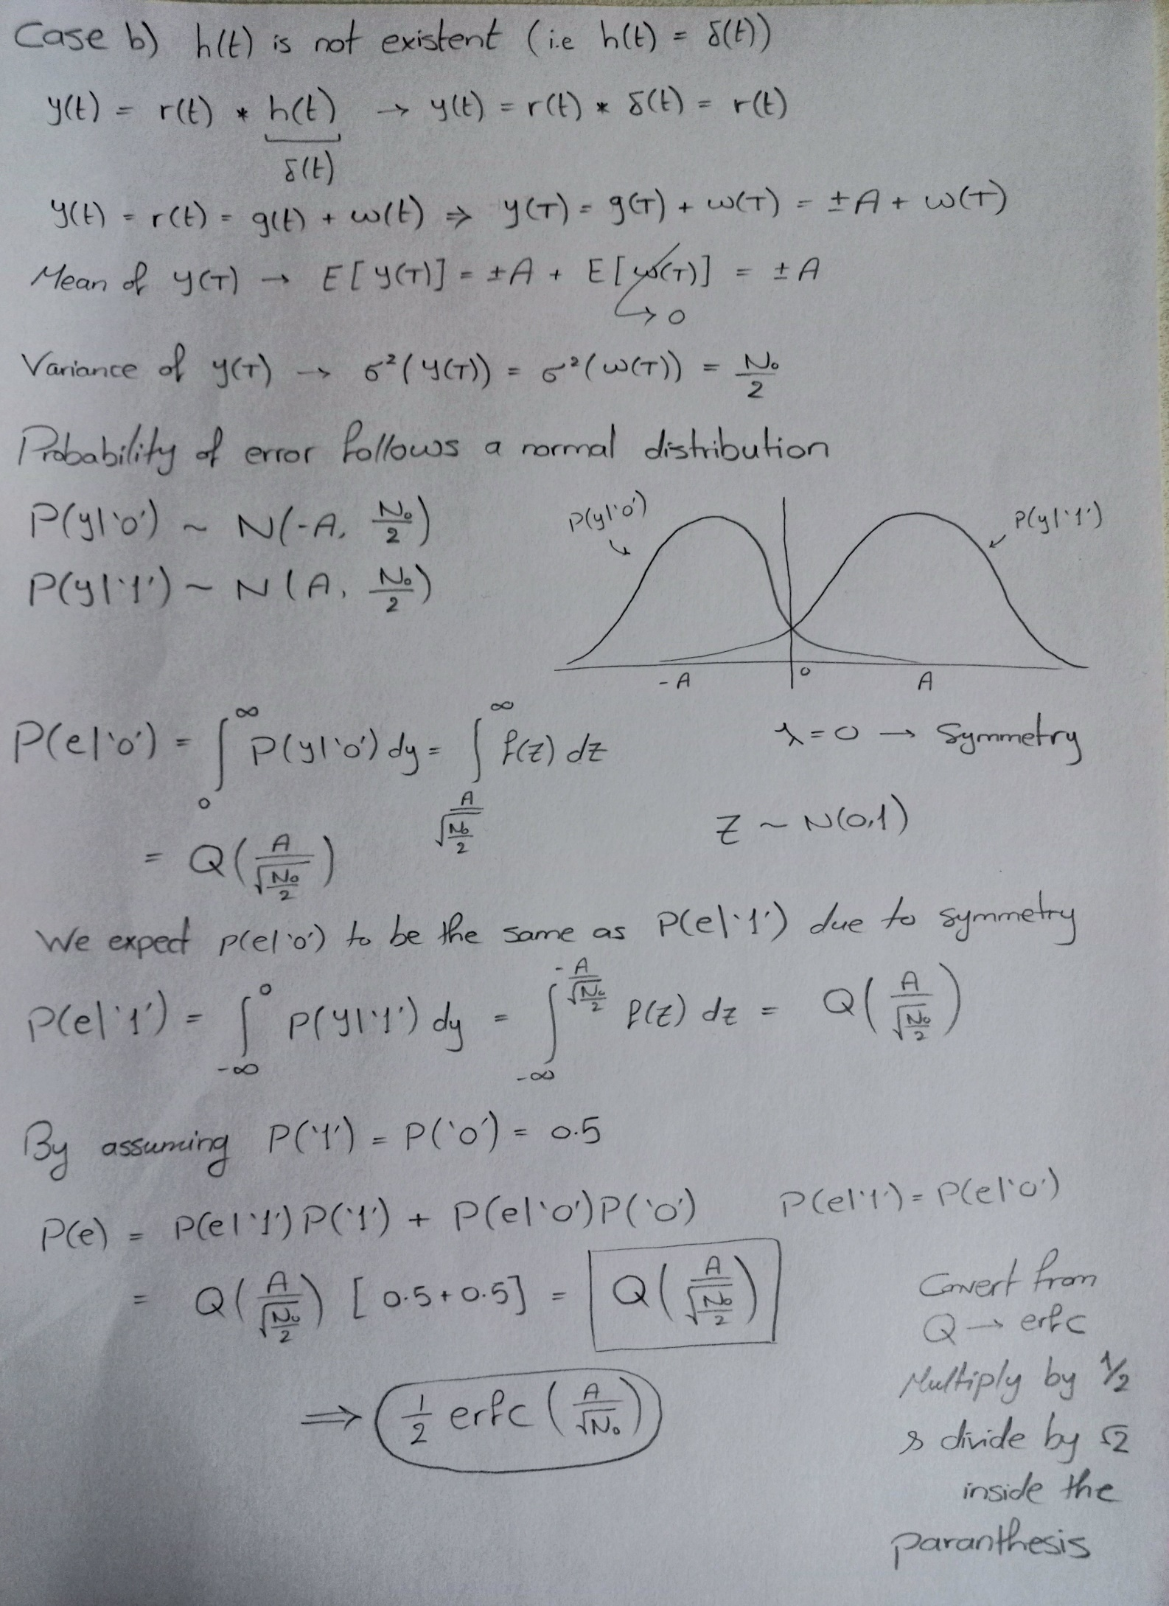

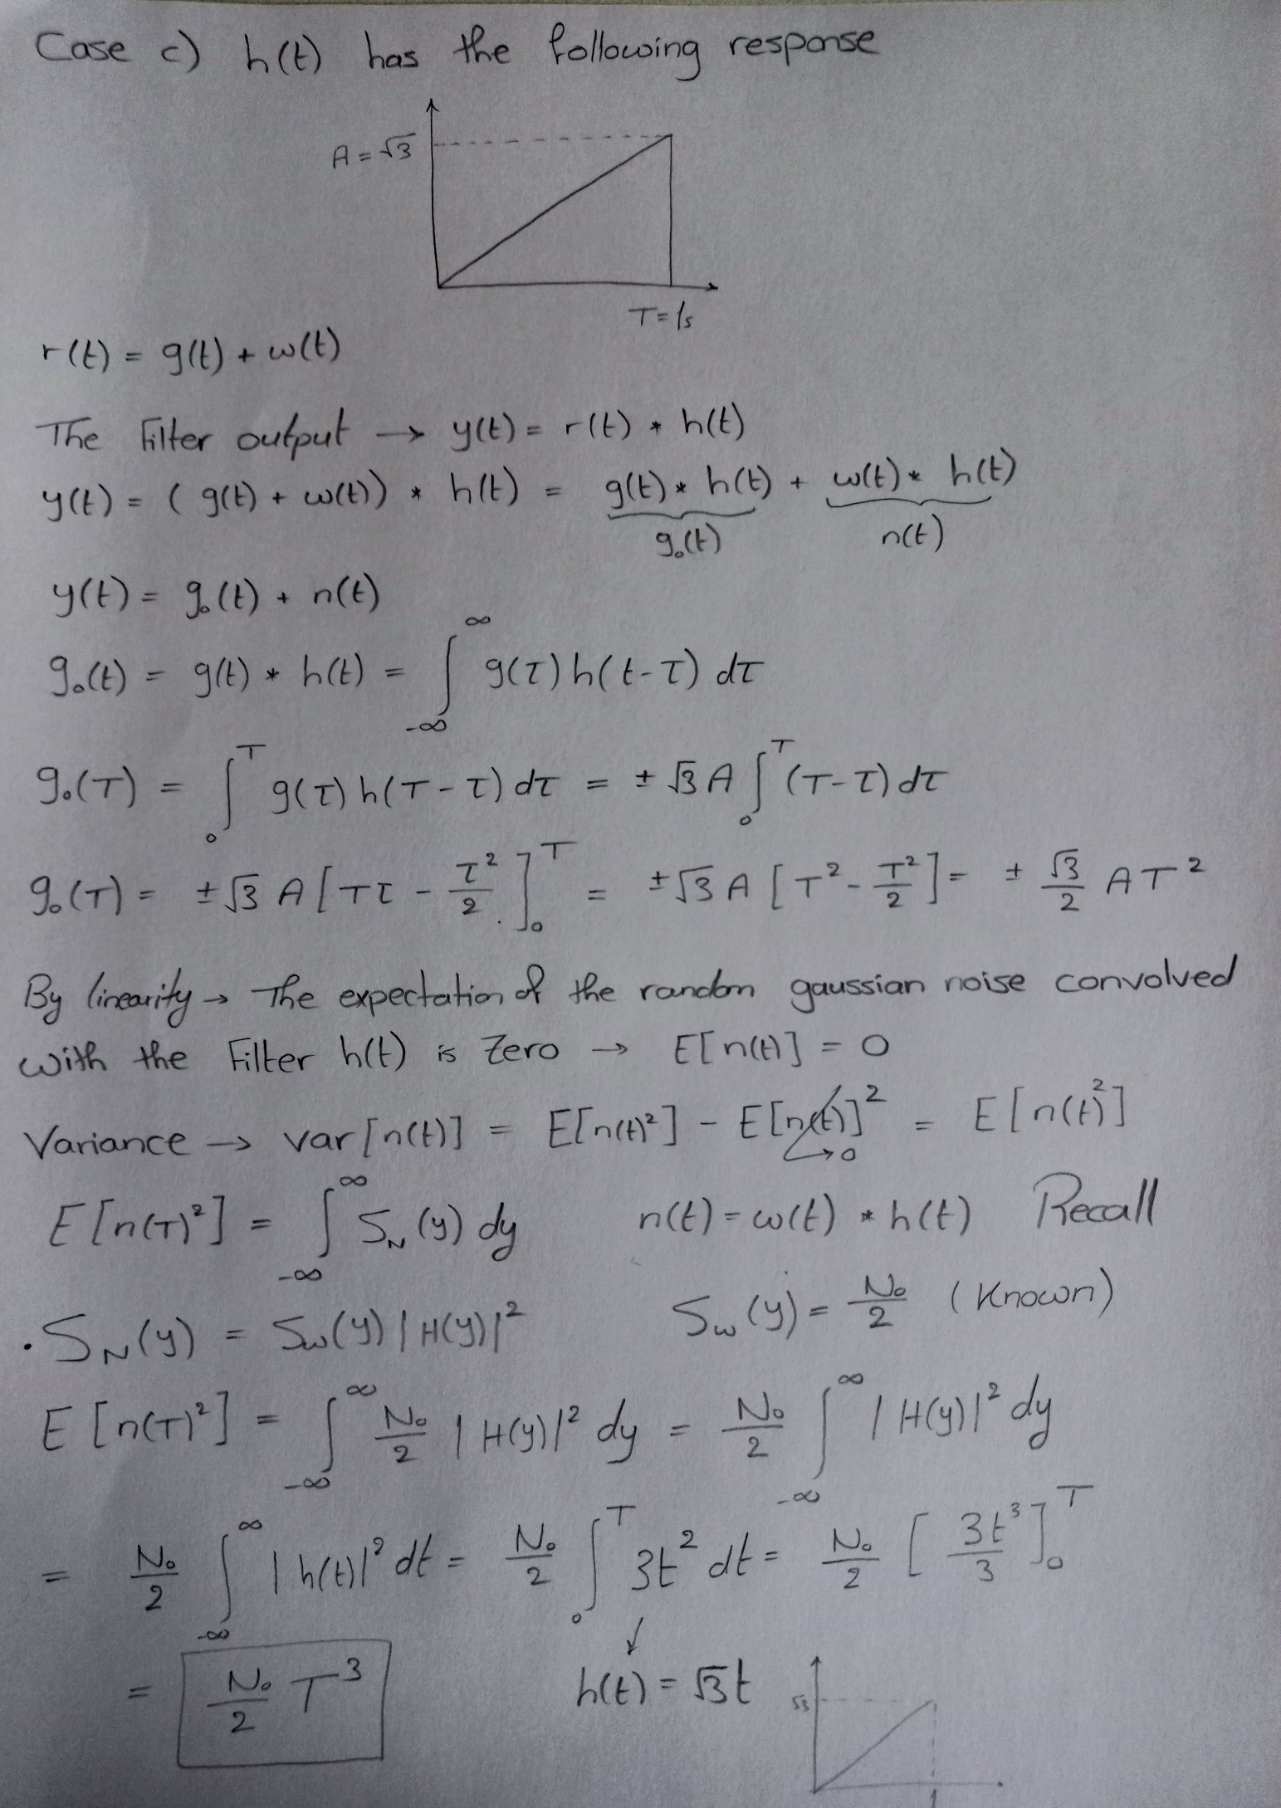

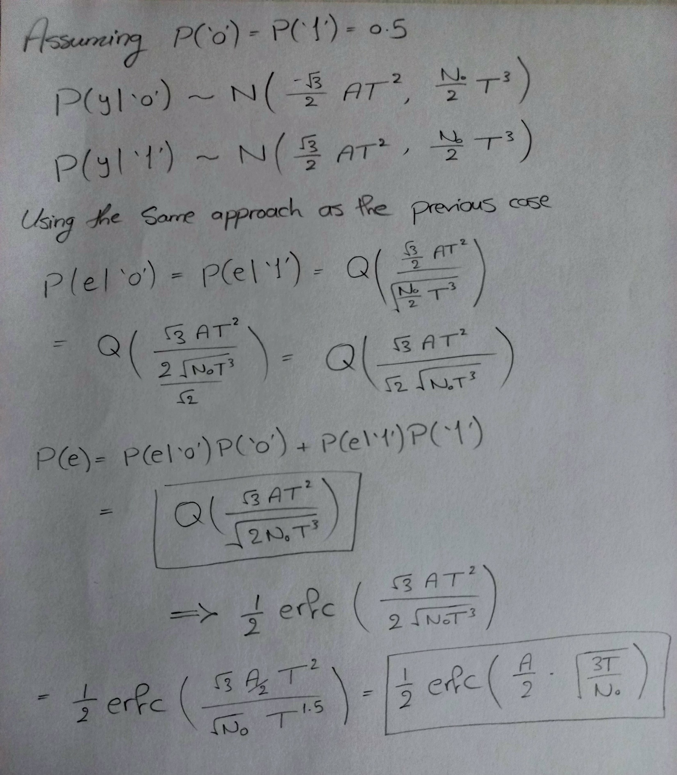

**Filter outputs**

**Number of bits = 10 and one pulse of duration 1 has 20 samples**

**Filter 1 output**

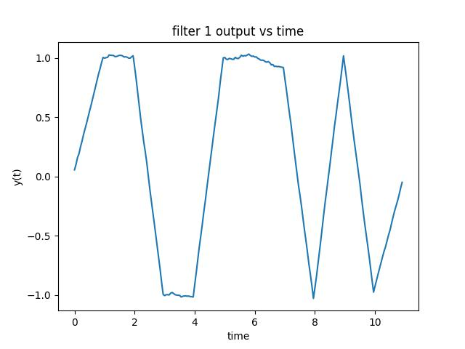

**Filter 2 output**

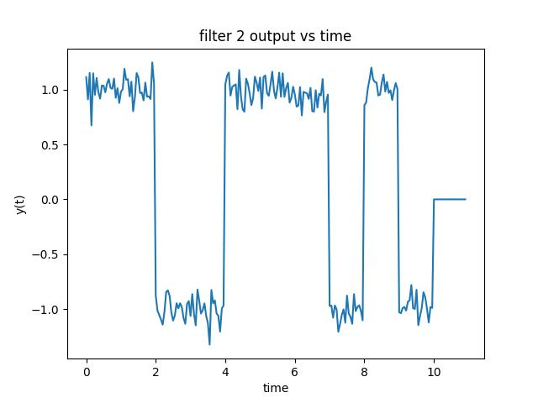

**Filter 3 output**

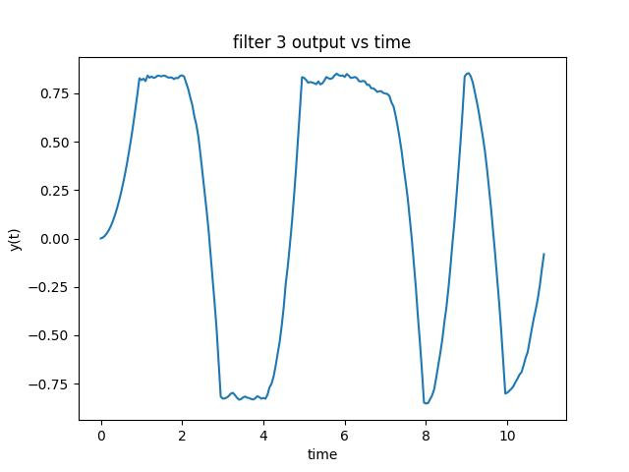

**Theoretical and simulated Bit Error Rate (BER) Vs**

**E/No:**

**Number of bits = 1000000 and one pulse of duration 1 has 20 samples**

